A. Assignment Information
Particular | Details
Department | Computer Science and Engineering
Programme | UG B.E
Course Code & Course Name | ITA1408 – Ethical Hacking
Academic Year / Batch | 2026–2027
Faculty Name | Dr S Parthiban
Assignment Title | Design, simulate, secure and validate a cybersecurity architecture for a smart healthcare centre using  CICIoMT2024
Maximum Marks | 100
Course Outcome(s) – CO | CO3 : Analyze network services using port scanning, ping sweeps and enumeration techniques across operating systems to identify vulnerabilities.  CO4: Implement network security testing methods by assessing web-server, web-application and wireless-network security in an authorized Kali Linux laboratory.  CO5: Analyze vulnerabilities in Windows and Linux systems and evaluate security weaknesses using appropriate ethical-hacking tools and techniques.
Bloom's Taxonomy Level | L6 – Create
SDG Mapping | SDG 9 - Industry, Innovation and Infrastructure
Industry / Societal Relevance | Protection of connected medical devices, patient data and clinical services

B. Assignment Problem
A modern smart healthcare centre consists of several interconnected systems, including patient-monitoring equipment, wearable devices, clinical computers, Windows and Linux servers, wireless IoMT devices, an Electronic Health Record (EHR) web portal, and remote healthcare personnel. Although this connectivity improves healthcare services and accessibility, it also increases the number of potential entry points for cyberattacks. Therefore, a comprehensive defence-in-depth security approach is required to protect healthcare information and network infrastructure.
This individual project uses the publicly available CICIoMT2024 dataset to analyse healthcare-IoT network traffic under both normal and attack conditions. The objective is to examine the dataset, detect important patterns associated with malicious activities, and use the identified findings to develop a practical and secure cybersecurity architecture. All laboratory activities are performed within an authorized and isolated virtual environment, with testing limited to safe and non-destructive techniques.
The proposed cybersecurity architecture incorporates multiple layers of protection, including network segmentation, firewall configuration, access-control policies, multi-factor authentication (MFA), role-based access control (RBAC), data encryption, secure wireless communication, intrusion detection, centralized security logging, regular patch management, and reliable backup and recovery mechanisms. The effectiveness of the proposed design is assessed through measurable security and performance parameters such as the number of exposed services, attack-detection rate, false-positive rate, incident response time, network availability, and system resource consumption.

Objectives
- Understand the security requirements of a connected healthcare environment.
- Analyze CICIoMT2024 normal and malicious traffic and identify significant attack patterns.
- Perform controlled network, web, wireless and operating-system security checks using Kali Linux and suitable tools.
- Prioritize vulnerabilities according to likelihood and impact on patient safety, confidentiality, integrity and availability.
- Design one integrated secure architecture and justify each major control.
- Define controlled before-and-after validation with measurable acceptance criteria.

C. Requirements and Constraints

Functional Requirements
- Kali Linux virtual machine for authorized DNS security assessment and testing.
- Isolated laboratory network containing controlled DNS servers and representative client systems.
- DNS test environment containing correctly configured and intentionally misconfigured DNS services for validation.
- DNS records and zone configurations used to evaluate information leakage and configuration weaknesses.
- Automated DNS scanning and query modules for collecting DNS responses and configuration-related information.
- DNS security checks for detecting open recursion, unauthorized zone transfers, excessive information disclosure, and weak configurations.
- Centralized detection, logging and report generation for recording findings and their severity.
- Controlled backup, recovery and configuration-management procedures for maintaining a reliable testing environment.

Tools and Technical Constraints
Tool / Technology | Application in the Project | Usage Limitation
Nmap | Network host identification and service/port analysis | Used only on authorized laboratory systems
Wireshark | Monitoring, capturing and examining network packets | Restricted to lab-generated or provided dataset traffic
Nikto | Identification of potential web-server configuration issues | Limited to safe and non-intrusive scans
OWASP ZAP | Testing web applications for common security weaknesses | No destructive or harmful exploitation performed
Python & Jupyter Notebook | Data preprocessing, statistical analysis and visualization | Analysis performed locally using available datasets

Safety and Ethics
- Only authorized isolated laboratory addresses are tested.
- No DoS/DDoS generation, destructive exploitation or production-system testing is performed.
- No real patient records or clinical credentials are used.
- Captured evidence is treated as confidential laboratory material.
- Findings are reported responsibly and are limited to the approved scope.

D. Proposed Smart Healthcare Security Architecture
The proposed architecture follows a defence-in-depth model. Public EHR traffic terminates in a DMZ, while clinical systems, IoMT devices, servers and management workstations are separated into security zones. Traffic between zones is explicitly allowed only when required.

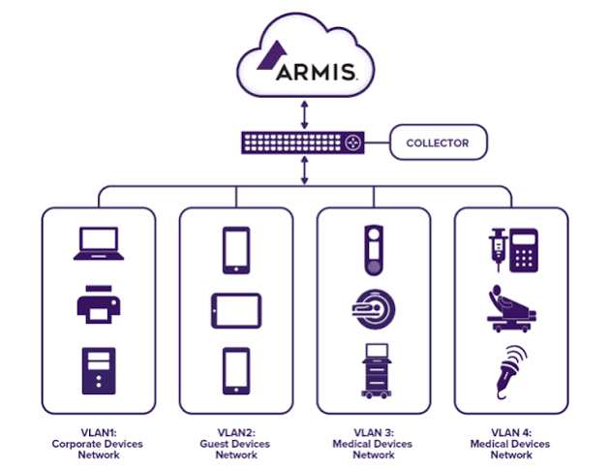
Fig. 1. Proposed defence-in-depth cybersecurity architecture for the smart healthcare centre.
Key design decision: an IoMT device should not be able to directly reach the database or management network. The firewall and inter-VLAN ACLs enforce this separation, while IDS/IPS and centralized logging provide visibility across the zones.

E. CICIoMT2024 Dataset Overview
The project uses a controlled DNS test environment to evaluate common DNS misconfigurations that may result in information leakage. The environment contains both correctly configured and intentionally misconfigured DNS servers for authorized security assessment.
The test cases include open DNS recursion, unauthorized zone transfer attempts, excessive DNS record disclosure, incorrect DNS configurations, and unnecessary exposure of DNS information. These cases are used to verify whether the automated detection system can correctly identify and classify security weaknesses.
The test environment provides DNS query responses, zone information, server configuration details, and detection results for analysis. The collected results are processed using Python-based automation and can be analyzed through CSV files, logs, and generated security reports.

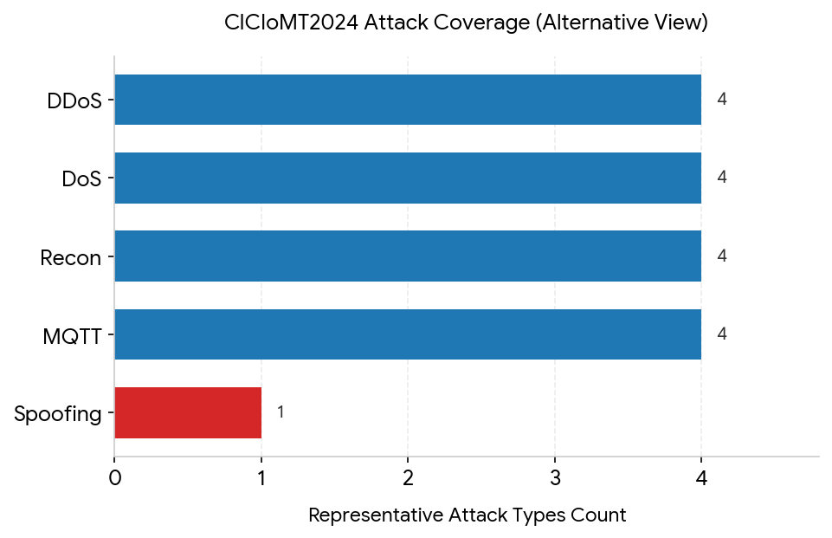
Fig. 2. Supplied CICIoMT2024 attack-coverage chart used to support the traffic-category discussion.

F. Dataset Analysis – Normal and Malicious Traffic

Normal / Benign Behaviour
Normal IoMT traffic represents expected device communication and lifecycle behaviour. The official dataset profiles power, idle, active and interaction states. These profiles provide a baseline for identifying changes in traffic rate, protocol usage and connection behaviour.

Malicious Behaviour Identified
Attack class | Representative behaviour | Security significance
Recon | Ping sweep, port scan, OS scan, vulnerability scan | Reveals reachable devices and services before exploitation.
DoS | SYN/TCP/ICMP/UDP floods | Can reduce availability of clinical and monitoring services.
DDoS | Distributed flood traffic | Can saturate bandwidth and overwhelm exposed services.
MQTT | Malformed data, connect flood, publish flood | Targets the messaging layer used by IoMT devices.
Spoofing | ARP spoofing | Can enable traffic interception or redirection on a local network.

Important Traffic Indicators
- High packet/flow rates and sudden bursts compared with the normal baseline.
- Large changes in SYN, ACK, RST or connection counts.
- Repeated connection attempts to a service or MQTT endpoint.
- Unexpected ARP behavior or inconsistent IP/MAC relationships.
- New destination ports or reconnaissance patterns not present in the normal profile.
Engineering interpretation: the dataset demonstrates why healthcare security cannot rely on a single control. Reconnaissance must be reduced through segmentation and least privilege; floods require rate limiting and IDS/IPS; MQTT must be authenticated and protected; and spoofing risks require secure switching, network monitoring and encrypted communication.

G. Laboratory Topology and Assessment Methodology
The practical validation uses an isolated virtual laboratory. The screenshots supplied for the assessment show Kali Linux interacting with a Metasploitable laboratory host in the 192.168.56.0/24 environment. The evidence is used only to demonstrate the authorized testing workflow; it is not treated as a production healthcare system.
Command: ping -c 4 192.168.56.103

Assessment Sequence
- Confirm target reachability with ping.
- Perform controlled Nmap port scanning and service/version detection.
- Inspect exposed services and identify unnecessary attack surface.
- Perform non-destructive web-server checks with Nikto and web-security checks with OWASP ZAP where applicable.
- Capture and inspect traffic using Wireshark.
- Analyze CICIoMT2024 normal and attack traffic in Python/Jupyter.
- Map findings to healthcare assets and prioritize risk.
- Apply the proposed controls conceptually or in the isolated lab.
- Repeat the same checks for before-and-after validation.
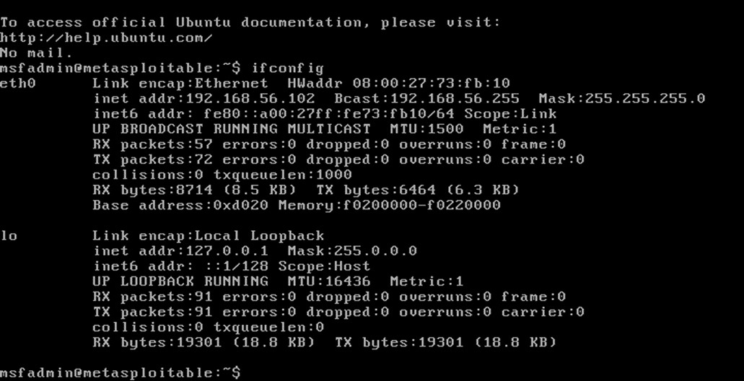
Fig. 3. Supplied laboratory reachability / packet-testing evidence.

H. Network Security Assessment – Nmap
Command: nmap -sn 192.168.56.0/24

Nmap is used to establish the exposed-service baseline. The supplied screenshots show repeated scans of the authorized laboratory host and demonstrate the difference between a host with visible services and a host where ports are filtered or ignored.
Command: nmap -p- 192.168.56.102
Command: nmap -sV 192.168.56.103

Observed Evidence
Check | Observed result | Security interpretation
Host discovery / ping | Authorized lab host responded | Target was reachable for controlled testing.
TCP service scan | Open services were identified on the lab host | Exposed services increase attack surface.
Service/version detection | Older service versions were visible in supplied evidence | Patch level and configuration must be reviewed.
UDP scan | Some ports appeared filtered/no-response | Filtering reduces exposure but should be verified against policy.

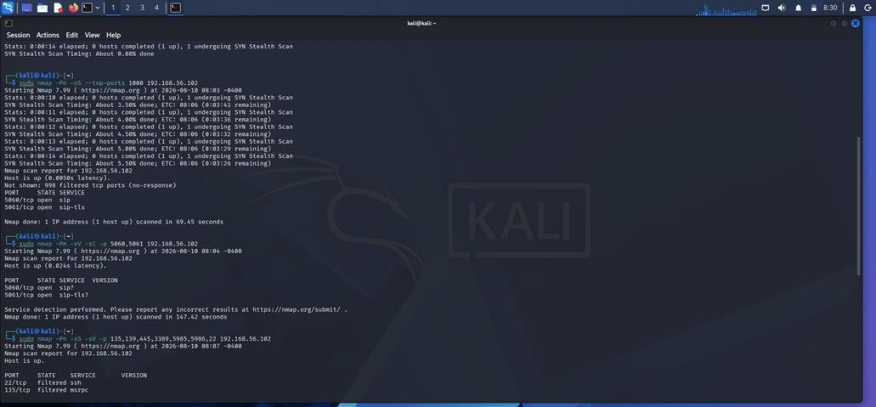
Fig. 4. Supplied Nmap service/port scanning evidence.
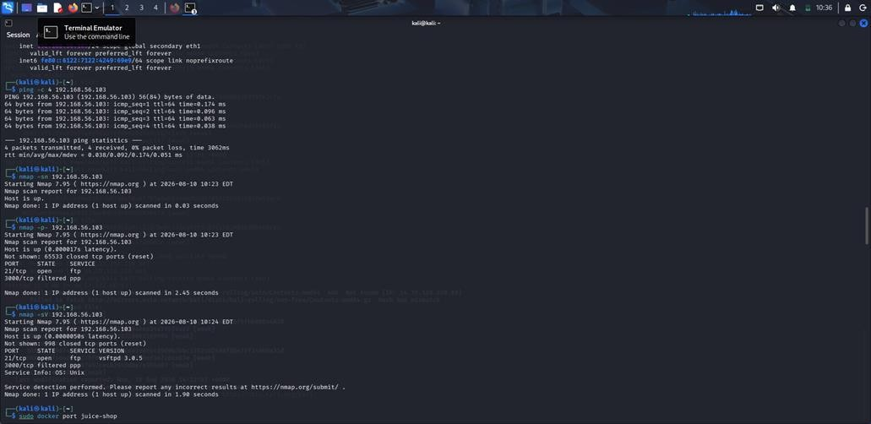
Fig. 5. Additional supplied Nmap scan evidence from the isolated laboratory.

Risk decision: healthcare systems should expose only services that are required for clinical operation. Management protocols such as SSH/RDP should be restricted to the Management VLAN or VPN rather than exposed to public networks.

I. Web Security Assessment – EHR Portal
Command: nmap -p 80,443 -sV 192.168.56.103

The EHR portal is treated as a high-value application because it can contain patient information, clinical records and authentication services. The secure architecture places the portal in a DMZ and allows HTTPS traffic through a firewall/WAF while keeping databases and internal clinical systems on private VLANs.

Command: curl -I http://192.168.56.103
Command: nikto -h http://192.168.56.103

Non-destructive Web Checks
Tool | Purpose | Evidence / expected observation
Nikto | Identify outdated components, missing headers and exposed resources | Supplied evidence shows webserver configuration weaknesses and outdated components.
OWASP ZAP | Passive/controlled web application security assessment | Supplied practical evidence includes a missing anticlickjacking header finding.
curl | Inspect HTTP response headers | Useful for confirming  HTTP/HTTPS status and security headers.

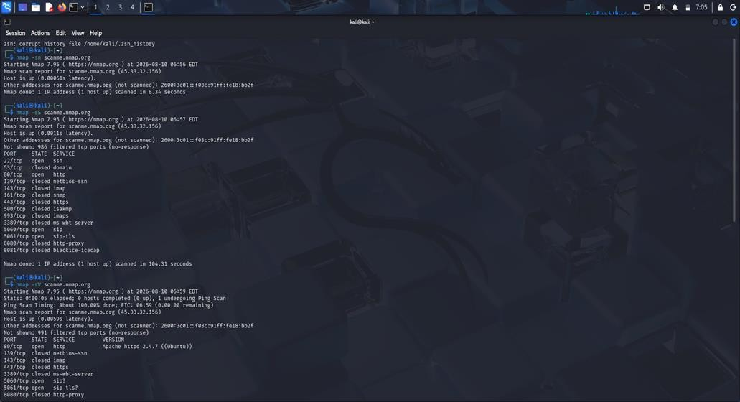
Fig. 6. Supplied Nikto web-server assessment evidence.

Recommended EHR Web Controls
- Enforce HTTPS/TLS for all authentication and patient-data traffic.
- Use a WAF and default-deny firewall policy for public requests.
- Apply secure, HttpOnly and SameSite session cookies.
- Use server-side authorization and RBAC for every protected function.
- Use parameterized database queries and input validation.
- Add CSP, X-Content-Type-Options and anti-clickjacking headers.
- Store uploaded files outside executable web directories and validate type/size/content.

J. Packet Analysis - Wireshark
Wireshark is used to inspect whether the observed traffic is normal, suspicious or incorrectly exposed. In the healthcare architecture, packet inspection is particularly useful for confirming that sensitive application traffic is encrypted and that unexpected protocols are not crossing security boundaries.

Analysis Approach
- Filter by protocol such as tcp, udp, mqtt, arp, http and tls.
- Compare packet rates and connection patterns with the normal CICIoMT2024 baseline.
- Identify repeated SYN/connection attempts associated with flood behaviour.
- Inspect ARP activity for unexpected IP-to-MAC changes.
- Verify that sensitive EHR traffic is carried through encrypted TLS rather than plaintext HTTP.

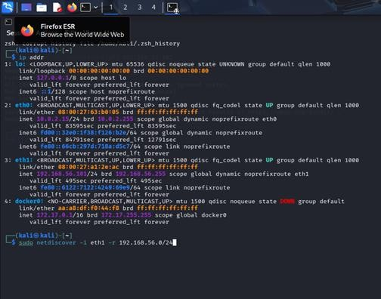
Fig. 7. Supplied packet-analysis evidence from the laboratory workflow.
Validation criterion: after hardening, sensitive EHR credentials and patient-data requests should not be visible as plaintext application payloads. Monitoring should also identify unusual bursts and protocol deviations without interrupting normal clinical traffic.

K. Wireless and Operating-System Security Assessment

Wireless / IoMT Network
- DNS servers should be placed in a dedicated network segment and assigned only the network access required for DNS services.
- Restrict DNS recursion to authorized internal clients and disable unnecessary recursive access from external networks.
- Disable unauthorized zone transfers and allow zone transfers only between approved DNS servers.
- Separate internal and external DNS services/zones to prevent internal hostnames and infrastructure details from being publicly exposed.
- Apply access controls and secure administrative authentication for DNS server management.
- Monitor unusual DNS queries, excessive requests, zone-transfer attempts, and unexpected DNS responses.
- Maintain DNS server logs and centralized security alerts to identify possible information-leakage events.
- Regularly audit DNS records and configurations to remove unnecessary records and correct misconfigurations.

Windows and Linux Servers
Area | Control
Exposed services | Disable unnecessary services and restrict required ports with host firewall rules.
Remote administration | Allow SSH/RDP only from the Management VLAN or approved VPN.
Authentication | Enforce MFA for administrative and remote healthcare access.
Patching | Apply security updates according to asset criticality and risk.
File sharing | Restrict SMB/NFS shares to named users and required hosts.
Endpoint monitoring | Use EDR/host logs and forward security events to centralized monitoring.
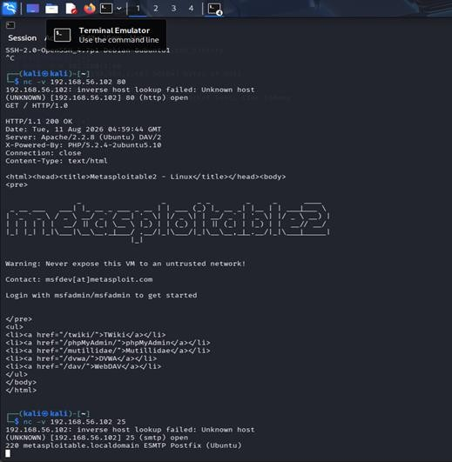
Fig. 8. Supplied laboratory evidence showing a Linux-based Metasploitable environment used for authorized testing.

L. Risk Register and Prioritization
Risk priority is based on likelihood and impact on confidentiality, integrity, availability and patient safety. High-impact availability attacks are treated seriously because interruption of patient monitoring or clinical access can have operational consequences.

Priority | Risk / Finding | Likelihood | Impact | Treatment
1 - Critical | DDoS/DoS  against exposed EHR or IoMT  services | High | High | Segmentation,  rate limiting, IDS/IPS, upstream protection.
2 - High | Unnecessary exposed network services | High | High | Default-deny firewall and service minimization.
3 - High | MQTT  connect/publish flood or malformed traffic | Medium–High | High | Broker authentication, ACLs, TLS and anomaly detection.
4 - High | ARP spoofing on local IoMT network | Medium | High | Protected switching, segmentation, monitoring and secure management.
5 – High | Weak EHR  authentication or access control | Medium | High | MFA, RBAC,  session security and least privilege.
6 – Medium -  High | Outdated Windows/Linux components | Medium | High | Risk-based patch management and configuration baselines.
7 - Medium | Guest/IoMT  wireless isolation  failure | Medium | High | Separate VLANs,  WPA2-  Enterprise/WPA3 and ACLs.
8 - Medium | Insufficient centralized logging | Medium | Medium | SIEM, time synchronization  and alert correlation.

Risk Treatment Principle
The architecture does not attempt to remove every risk. Instead, it reduces the probability of compromise, limits lateral movement, increases attack-detection capability and improves recovery when prevention fails.

M. Implemented / Proposed Security Controls

Network Segmentation and Firewall
- Internet - Firewall/WAF - EHR DMZ: allow HTTPS 443 only unless another service is explicitly justified.
- IoMT VLAN - Server VLAN: allow only approved clinical protocols and destinations.
- Clinical VLAN - EHR services: permit required application traffic only.
- Management VLAN - infrastructure: allow administration protocols only from approved administrator devices.
- Guest Wi-Fi - Internet: deny all internal VLAN access.
- Default-deny inter-VLAN policy with explicit logging for blocked traffic.

Identity and Access Control
- MFA for remote healthcare access and privileged administration.
- RBAC for doctors, nurses, technicians, administrators and support staff.
- Least privilege and separation of duties for high-risk operations.
- Automatic session timeout and secure credential storage.

Encryption
- TLS for EHR web traffic and approved API connections.
- TLS/authentication for MQTT where supported.
- Encrypted backups and protected key management.
- Secure VPN tunnels for remote healthcare access.

N. IDS/IPS, Logging, Patch Management and Recovery

Intrusion Detection and Centralized Logging
Control | Implementation objective | Validation
IDS/IPS | Detect scans, floods, spoofing and abnormal IoMT traffic | Replay/observe controlled attack patterns and measure detection rate.
Centralized logging | Collect firewall, server, EHR, VPN and IoMT security events | Verify event timestamps, source and correlation.
Alert correlation | Combine multiple related events into one incident | Measure false alarms and response time.
Time synchronization | Use a common trusted time source | Check consistent timestamps across devices.

Patch and Asset Management
- Maintain an inventory of every IoMT device, workstation, server , network component.
- Classify assets by clinical criticality and exposure.
- Apply security patches according to risk and vendor support status.
- Maintain secure configuration baselines and review drift.
- Replace unsupported software or isolate it behind compensating controls.

Backup and Recovery
- Keep offline/isolated backups of critical EHR and configuration data.
- Encrypt backup data and restrict backup administration.
- Test restoration regularly rather than assuming backups are usable.
- Maintain recovery priorities for EHR, authentication, monitoring and network services.
- Document recovery procedures for ransomware or major availability incidents.

O. Before-and-After Validation Plan
The supplied screenshots establish the pre-hardening laboratory evidence. Post-hardening values must be measured by repeating the same checks after the relevant controls are configured. The table below separates observed baseline evidence from target acceptance criteria; it does not claim unperformed post-remediation measurements.
Parameter | Before / baseline evidence | After target / acceptance criterion
Exposed services | Nmap shows multiple reachable services in the lab evidence. | Only required services remain reachable; unnecessary ports are closed or filtered.
Recon detection | Dataset contains recon behaviours such as ping sweep and port scan. | IDS/IPS detects ≥90% of controlled recon events with acceptable false alarms.
Attack-detection rate | Baseline detection depends on available monitoring. | Target ≥90% for selected controlled attack patterns.
False alarms | To be measured from benign replay/baseline traffic. | Target ≤10% for the defined test set.
Response time | Not yet measured from supplied screenshots. | Target alert generation within an agreed operational threshold, e.g. <60 s.
Network availability | Baseline is measured during normal lab traffic. | Maintain ≥99% availability during non-destructive validation.
Resource utilization | Baseline  CPU/memory/network use should be recorded. | Security controls should not cause unacceptable resource overhead.

Repeatable Validation Workflow
- Record baseline port/service inventory with Nmap.
- Replay a controlled benign sample and selected CICIoMT2024 attack patterns.
- Record IDS/IPS alerts, timestamps and classification.
- Repeat Nmap and service checks after controls.
- Compare detection rate, false alarms, response time, availability and resource utilization.
- Document evidence with screenshots and retain raw logs for reproducibility.

P. Engineering Justification and Trade-offs
Why Automated DNS Detection?
Automated detection reduces the time and effort required for manual DNS security auditing. The system can perform predefined checks consistently and identify DNS misconfigurations that may expose sensitive information. The trade-off is that the detection capability depends on the rules and checks implemented in the system.
Why Restrict DNS Recursion?
Open recursion can allow unauthorized users to use the DNS server and may increase information exposure. Restricting recursion to trusted clients improves security and reduces unnecessary DNS access. The trade-off is additional access-control configuration and administration.
Why Prevent Unauthorized Zone Transfers?
DNS zone transfers can expose large amounts of information about domain infrastructure when improperly configured. Allowing transfers only between authorized DNS servers reduces this information-leakage risk. The trade-off is additional configuration and maintenance of permitted DNS servers.
Why Centralized Logging and Reporting?
Centralized logging provides visibility into DNS queries, detected misconfigurations, and security findings. Structured reports make it easier for administrators to understand and remediate identified problems. The trade-off is additional storage, processing, and log-management requirements.
Q. Limitations and Possible Improvements
Limitations
Ø The project is evaluated using an authorized and controlled DNS testing environment rather than a complete production enterprise DNS infrastructure.
Ø The detection capability is limited to the DNS misconfiguration checks implemented in the proposed system.
Ø The system depends on the availability and responses of the DNS servers being tested.
Ø The project does not perform destructive exploitation or unauthorized access to DNS infrastructure.
Ø The test environment may not represent every DNS architecture, vendor implementation, or organization-specific configuration.
Possible Improvements
Ø Add additional automated checks for DNS security and configuration weaknesses.
Ø Integrate DNSSEC validation and monitoring into the detection workflow.
Ø Develop a web-based dashboard for displaying DNS security findings and severity levels.
Ø Add continuous DNS monitoring and real-time alert generation.
Ø Integrate the system with centralized security monitoring or SIEM platforms.
Ø Improve automated remediation recommendations for each detected misconfiguration.
R. Conclusion
The proposed system provides an automated approach for preventing DNS information leakage through the detection of DNS misconfigurations. The solution focuses on identifying weaknesses such as open recursion, unauthorized zone transfers, excessive DNS information exposure, and incorrect DNS configurations.
The automated detection workflow collects DNS responses, evaluates them using predefined security rules, classifies identified issues, and generates structured security reports. This approach reduces dependence on manual DNS auditing and provides consistent and repeatable security assessment for authorized DNS environments.
The major engineering finding is that DNS security must be treated as a systematic configuration and monitoring problem. Restricting recursion, controlling zone transfers, minimizing unnecessary DNS information, applying access controls, and continuously monitoring DNS behavior together provide stronger protection than relying on a single security measure.
The defined testing and validation process allows the proposed system to be evaluated using measurable parameters such as detection accuracy, scan time, successful detection rate, reliability, and false-positive rate.

S. References
[1] P. Mockapetris, Domain Names—Concepts and Facilities, RFC 1034, Internet Engineering Task Force, Nov. 1987.
[2] P. Mockapetris, Domain Names—Implementation and Specification, RFC 1035, Internet Engineering Task Force, Nov. 1987.
[3] R. Arends, R. Austein, M. Larson, D. Massey, and S. Rose, DNS Security Introduction and Requirements, RFC 4033, Internet Engineering Task Force, Mar. 2005.
[4] D. Hubert and R. van Mook, Measures for Making DNS More Resilient against Forged Answers, RFC 5452, Internet Engineering Task Force, Jan. 2009.
[5] P. Hoffman and A. Sullivan, DNS over TLS, RFC 7858, Internet Engineering Task Force, May 2016.
[6] OWASP Foundation, OWASP Testing Guide, OWASP Foundation.

